

**Pandas Assignment**

[support@intellipaat.com](mailto:support@intellipaat.com)

+91-7022374614

US: 1-800-216-8930 (Toll Free)

**Instructions for the Assignment**

1. Use a single file in Jupyter Notebook or Goggle collab for the entire assignment.
2. Download the Assignment file (File> Download > Download as .ipynb), compress it in a Zip folder and submit through LMS only.
3. Use the given dataset (Tips.csv, Tips1.xlsx,) for this Assignment.
4. Submit the Assignment by 5th February 2022 without fail.
5. This Assignment is an Exam kind and is considered for the evaluation and certification. No support is provided by our technical team.
6. If you have any doubts how to work on this assignment (No technical support), please drop an email to [support@intellipaat.com](mailto:support@intellipaat.com)

**FINAL ASSIGNMENT**

1. Consider the following data to answer the question below

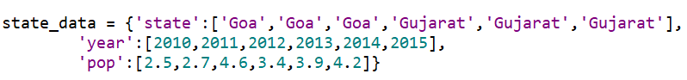

What is the command to convert the above dictionary into a dataframe named ‘df_state’?

1. List 3 commands to display the columns of the above dataframe df_state.
2. Correlation between two variables X&Y is 0.85. Now, after adding the value 2 to all the values of X, the correlation co-efficient will be______
3. A) Read the given dataset “Tips.csv” as a dataframe “Data”. Give 3 commands to extract the columns in the following sequence - Time, TotalBill, Tips?
4. Read the given excel sheet ‘Tips1.xlsx’ as a dataframe ‘Data1’. What command should be given to merge the two data frames ‘Data’ and ‘Data1’ by columns?
5. Copy the 'Data1' dataframe as 'Data2' (Data2 = Data1.copy()) and identify the command to find the total tips received across Day’s from the dataframe ‘Data2’?